2023 Spring New Members Immanuel Lutheran Church

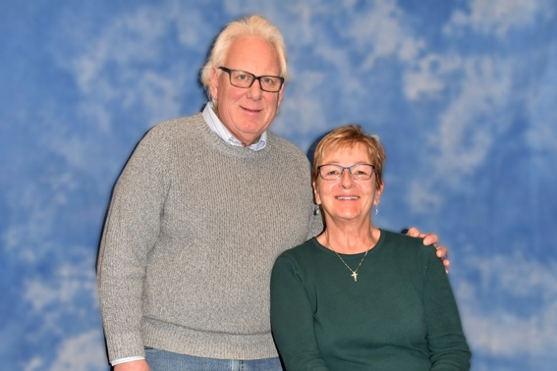
Perry, Karl & Mary Ellen 218-545-8639
23421 County Road 30
Aitkin, MN 56431 perry.mep@gmail.com
Church Mailbox 013

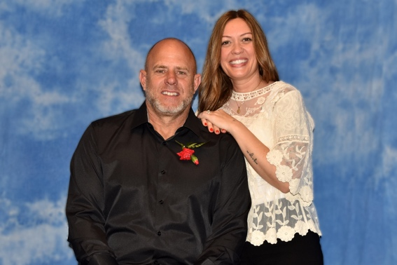
Turk, Brandon & Sally 218-851-7714 (Brandon)
204 5th Ave. SW. 218-866-2718 (Sally)
Crosby, MN 56441
Church Mailbox 003 sallyoren14@gmail.com

