August Progress Report 2022.
Average number of children fed (in hundreds):
900
Average number of feeding days per week:
6 days a week. Feeding is going on very well.
Number of high school students:
77
Number of boarding school students:
8
Status of High School attendees:
Students are still in school. 7 of our Form four students are waiting for MSCE Examinations. This is the final exams that determines whether they qualify for college or not. Pray for favorable results by the end of November.
University students
Blessings Tsonthi is back at the Lilongwe campus.
Precious and Leonard are doing well in School. Attached to this report are letters from Precious and Leonard.

Status of soap business:
The beneficiaries are doing their business after giving them seed money. The idea is that when they have made some profits the initial seed money will be given to a new team of beneficiaries who will at this point be trained by our first beneficiaries. This is to ensure that there is responsibility and giving back to the project by imparting the knowledge they have gained to others. We also continue to distribute tablets of soap to the children and volunteers.
Status of chicken/egg business:
More local chickens have been stocked. Egg laying chickens have been purchased.
Status of Kanyenyeva Wala:
The team continues to make kit components with the materials we have in stock. We are very thankful for all the DFG materials that the Westwood team brought to us, this will definitely go a long way. We also received some materials sent through the first mission team from Penny and many others who donated.

Status of the farm:
We have planted 1500 Blue Gum trees on our forest reserve strip at the farm. The tree seedlings have been transplanted into tubes in readiness for the rainy season for us to plant more trees. We have also applied pesticides on the blue gum trees that we planted last rainy season. Research was done on irrigation system and the team has concluded that the best way to irrigate the bananas as of now is by using a Wind Mill. We have part of the seed money for the first wind mill which will help water at least 2 -3 hectares.
Other:
Sports equipment and gym
We are very grateful for the balls, and jump ropes that the team brought. Our children were and are very happy for this wonderful gift. They now have a chance to play, have fun and just be kids. Many thanks to each and every one who donated and helped mobilize the resources.

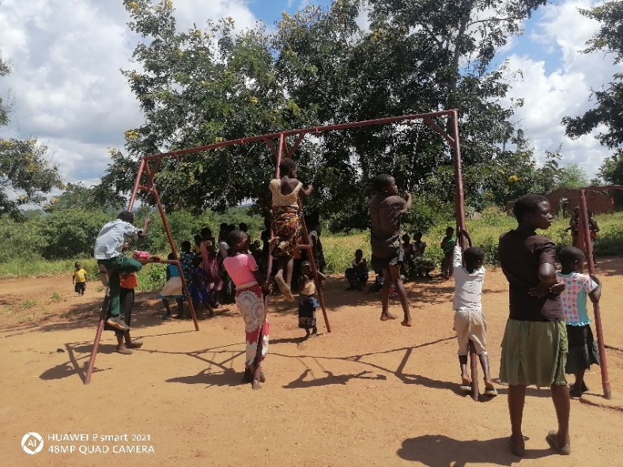

The well
A tower to hold the water tank has been built and connections have started. Complete installation of everything will be done by early October.
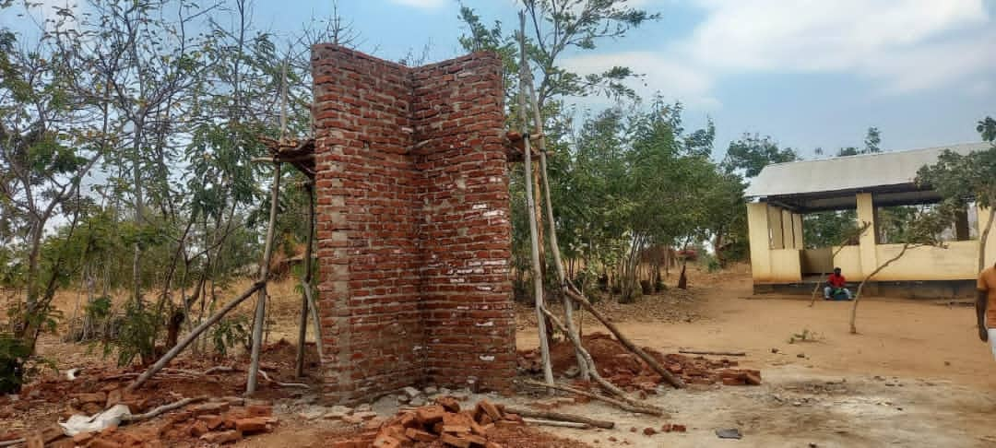

Mounting the tower for the well
Women volunteers and the committee
The women and the committee still remain strong and continue to serve the children with passion.
Maize mill
We are excited to report that construction of the maize mill building has started. We have also found a supplier for the maize mill who will also plant the mill when the building is complete.

