June Progress Report 2022.
Average number of children fed (in hundreds):
850
Average number of feeding days per week:
6 days a week. Feeding is going on very well.
Number of high school students:
73
Number of boarding school students:
8. Six in high school and two in college.
Status of National High School attendees:
Students are still in school.

Successful students
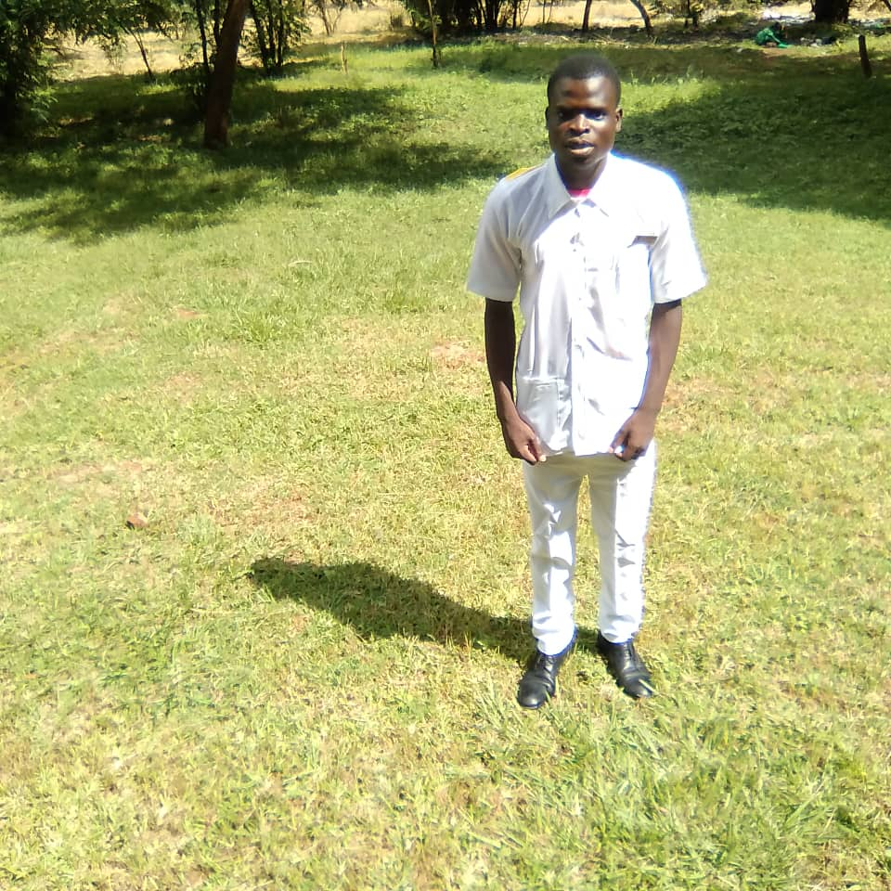
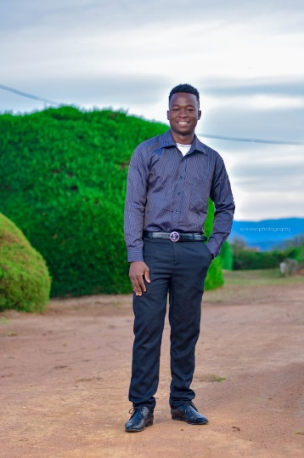

Precious Blessings
Precious Masula is still on holiday and is back home in Kanyenyeva. Him and Leonard have started tutoring form 4 students that will be sitting for their MSCE Examinations. This is an amazing thing to see, our college students helping and giving back to their community. Blessings Tsonthi is back on Lilongwe campus.
We have another wonderful news to share with you. Leonard Robiam has passed his MSCE Examinations. He has scored 27 points which is a bit lower, he is not qualified to apply for the national university entrance, but has passed well and can still be accepted in other community colleges. We are looking for different schools.
Our children at Kanyenyeva are growing up and most of them are working extra hard, it definitely is getting busy.
Status of soap business:
We continue to distribute tablets of soap to the children and volunteers and some is being sold by the beneficiaries.
Status of chicken/egg business:
The chicken house is complete and we wait to stock the chickens soon.
Status of Kanyenyeva Wala:
The team continues to make kit components with the few materials we have in stock. We were approached by a local Christian organization that wanted to buy DFG pods from us (1 shield, and 2 liners) for flood victims in Zomba. The condition was that apart from supplying the pods we also help purchase toothbrushes, toothpaste, soap, a 3-liter bucket, hand sanitizer and 2 panties for them. We accepted this challenge and we managed to source all the items they needed and we delivered 460 dignity packs within 3 days and the client was very happy. It was not an easy task but the team delivered.
Status of the farm:
We have planted 1500 Blue Gum trees on our forest reserve strip at the farm.
Other:
Sports equipment and gym
We need more balls, toys and other materials that the children can play with at the project. We are grateful that there is an initiative to buy balls by July that is going on.

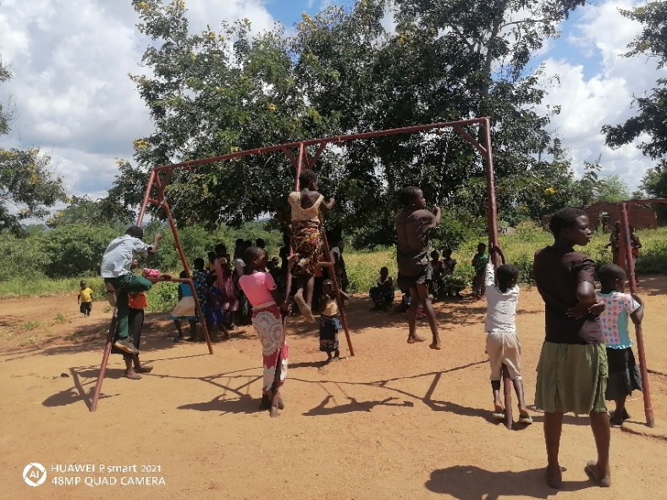

The well
We have found several options on the well. On how we can run by solar energy and provide running water for both the Skills Centre and the villages around. We agreed to wait on the plumbing work until the mission team is here.
Women volunteers and the committee
The women and the committee still remain strong and continue to serve the children with passion.
Clothes, and shoes
We would love to provide the children with clothes, and shoes as well, funds permitting. Most children rely on the clothes that the ministry has been providing to them and it has been some time since we did that.
Blankets
We bought and distributed the last consignment of blankets. We finally gave a blanket to each and every one of our children at Kanyenyeva. We have distributed blankets to the last 372 children from standard 7 all the way to High School. Precious, Lornard, the committee members and the volunteer cooks all received blankets. The money was enough to cover everyone. There was so much happiness, and gratitude from the children as well as the adults. Songs of joy and praise were all over because of this wonderful gift of a blanket. We are beyond grateful. We thank God for all of you who took part in raising funds for this to happen.
Maize mill
We are excited to report that construction of the maize mill building has started. We have also found a supplier for the maize mill who will also plant the mill when the building is complete.

