April Progress Report 2022.
Average number of children fed (in hundreds):
789
Average number of feeding days per week:
6 days a week. Feeding is going on very well.

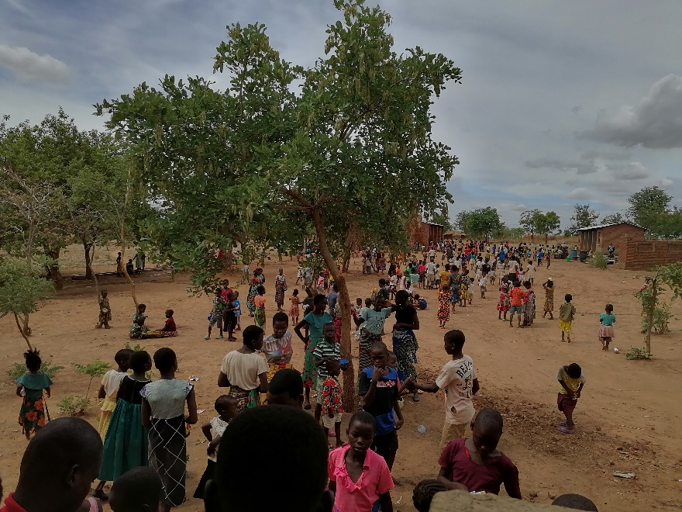

Number of high school students:
73
Number of boarding school students:
8. Six in high school and two in college.
Status of National High School attendees:
Students are back in school.

Successful students
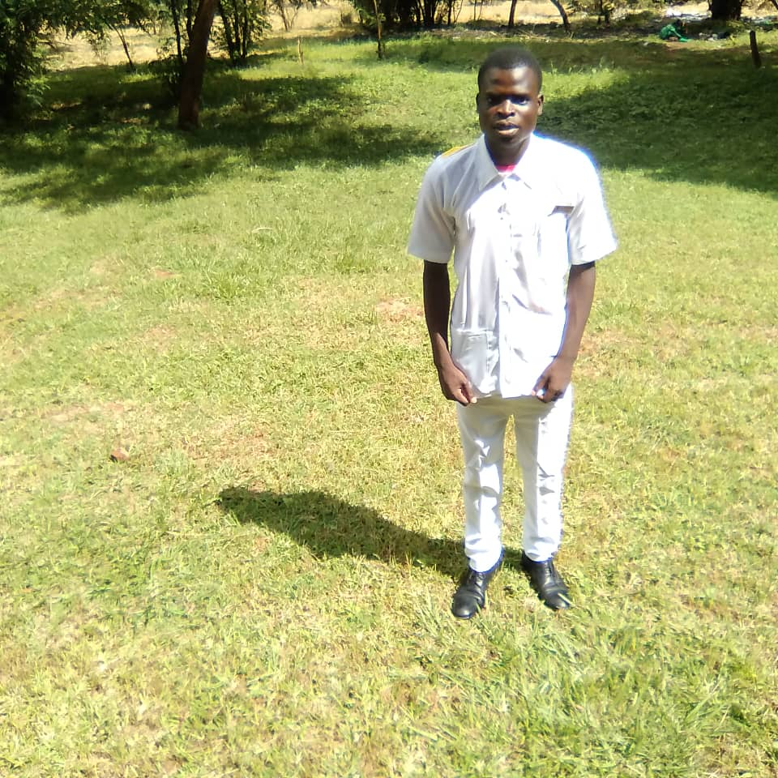
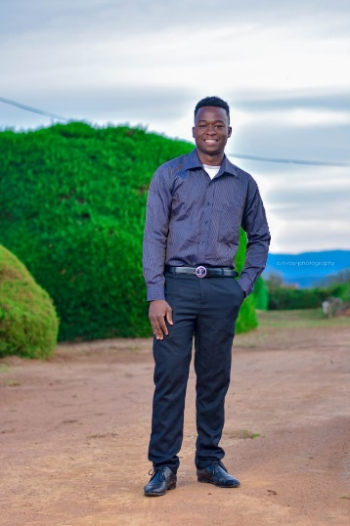

Precious Blessings
Precious Masula and Blessings Tsonthi are still in school and are doing well in their studies. It is very heartwarming to see the transformation these young men are going through.
We have another wonderful news to share with you. Leonard Robiam has passed his MSCE Examinations. He has scored 27 points which is a bit lower, he is not qualified to apply for the national university entrance, but has passed well and can still be accepted in other community colleges.
Our children at Kanyenyeva are growing up and most of them are working extra hard, it definitely is getting busy.
Status of soap business:
More soap is being made. We continue to distribute tablets of soap to the children and volunteers and some is being sold by the beneficiaries.
Status of chicken/egg business:
The chicken house is complete and we wait to stock the chickens soon.
Status of Kanyenyeva Wala:
We received a donation from anonymous donor to donate 50 smart starter kits to girls in the Kanyenyeva area from Days for Girls. Since our feeding program girls already got kits from the previous months we extended the gift to the primary school going girls at the school where our children attend. The school sent over 50 girls from standard 4 all the way to standard 8. The students were escorted by their female teacher who also attended our menstrual Hygiene training together with the girls. At the end of the trainings the girls and their teacher received the Days for Girls kits. The girls and their teacher were very grateful that we shared the kits with them and that this will help the girls attend school comfortably and will surely improve their school attendance.

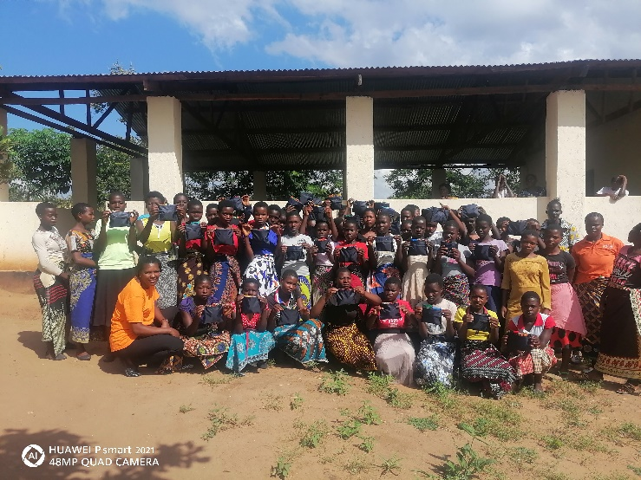
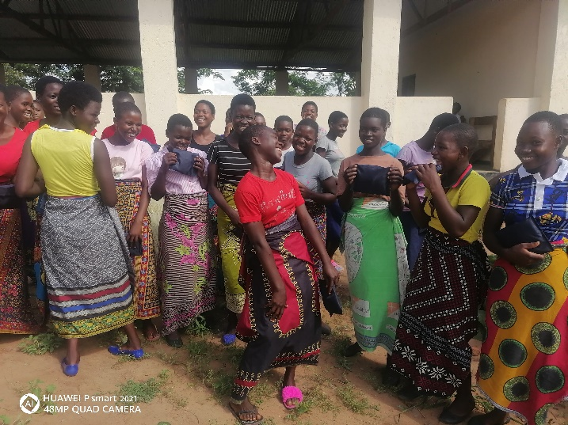
Primary school girls from Kawangwi. The happiness after receiving a DFG kit

Status of the farm:
We have planted 1500 Blue Gum trees on our forest reserve strip at the farm. The rains started late and have stopped early. We have not received rains since early march, this is some worrisome news.
Other:
Sports equipment and gym
We need more balls, toys and other materials that the children can play with at the project. We wait until we have enough funds for this. The current funds cannot be used for this program for now.
The well
We have found several options on the well. On how we can run by solar energy and provide running water for both the Skills Centre and the villages around. We agreed to wait on the plumbing work until the mission team is here.
Women volunteers and the committee
The women and the committee still remain strong and continue to serve the children with passion.
Clothes, and shoes
We would love to provide the children with clothes, and shoes as well, funds permitting. Most children rely on the clothes that the ministry has been providing to them and it has been some time since we did that.

Blankets
We are very thankful and excited to receive money for blankets. To God be all the glory. We have distributed blankets to the first 600 children from nursery school all the way to standard 6. This has come at the right time as the cold season has now started. This is surely a very thoughtful and wonderful gift for our children. We thank God for all of you who took part in raising funds for this to happen.
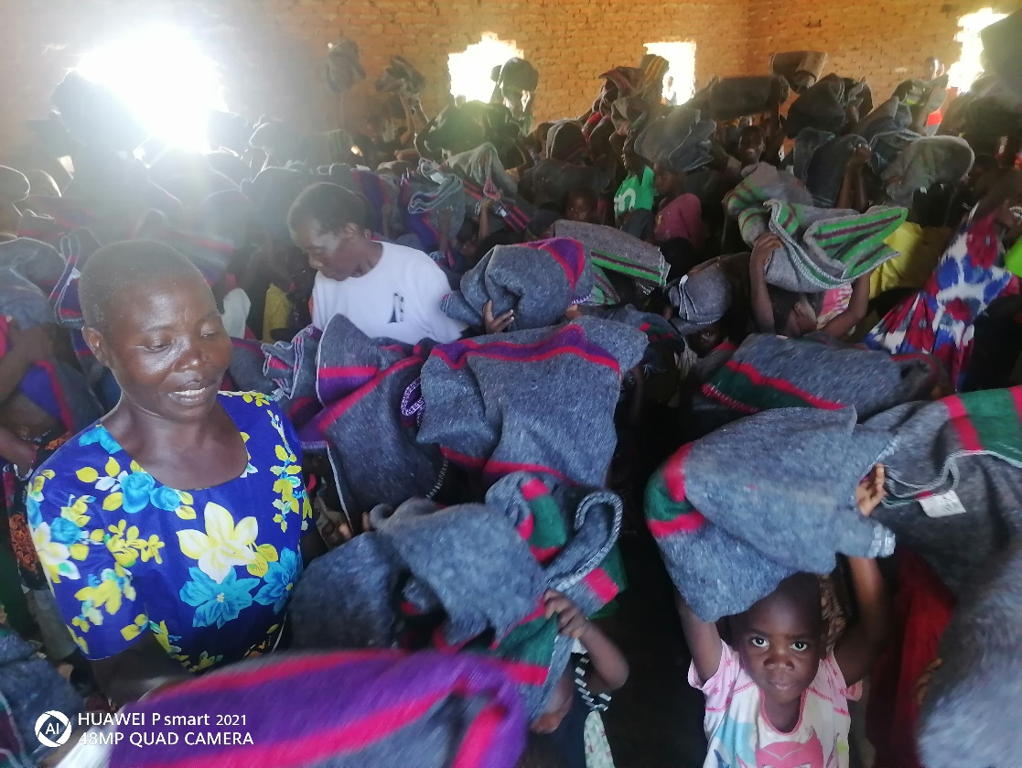

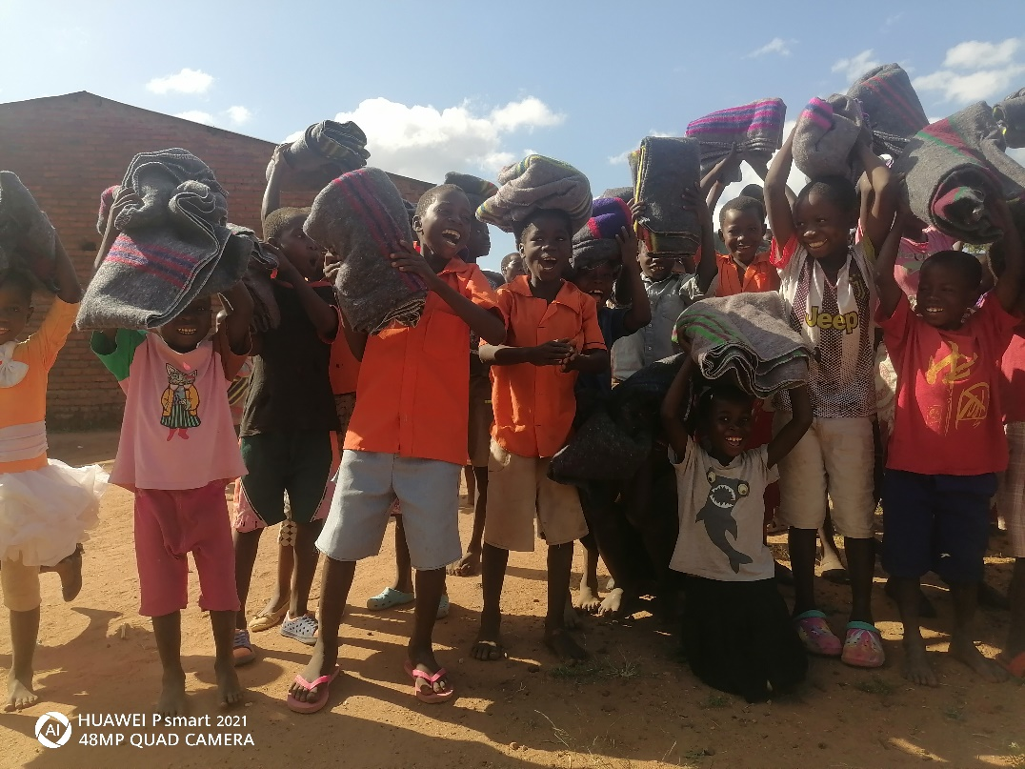
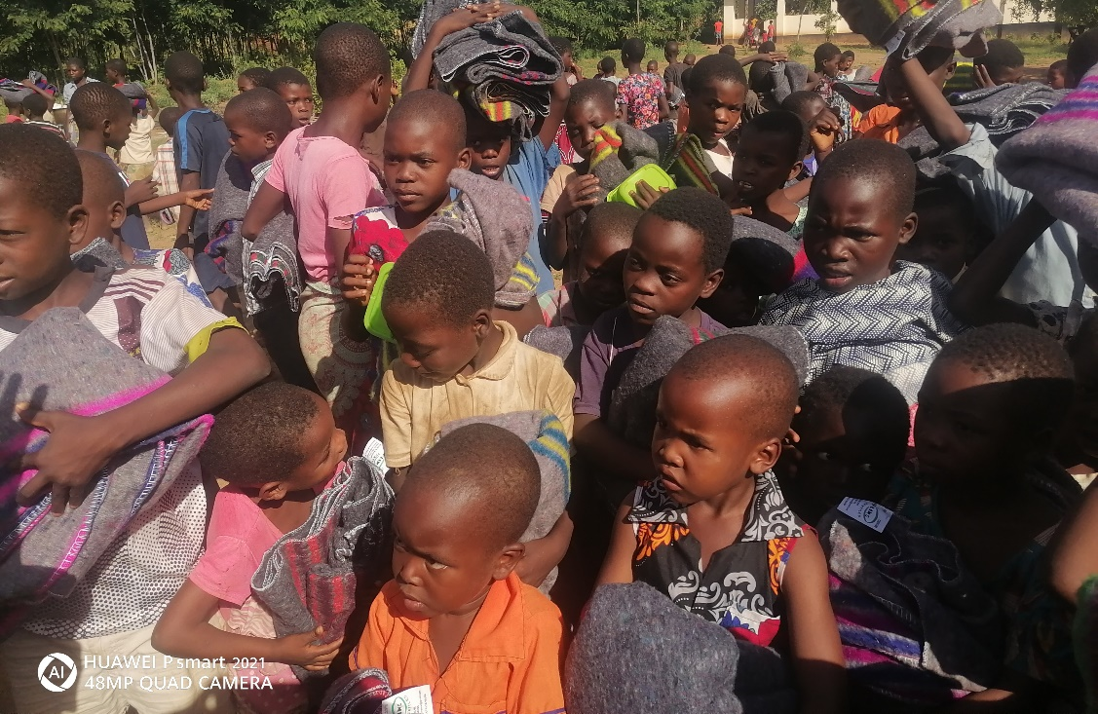

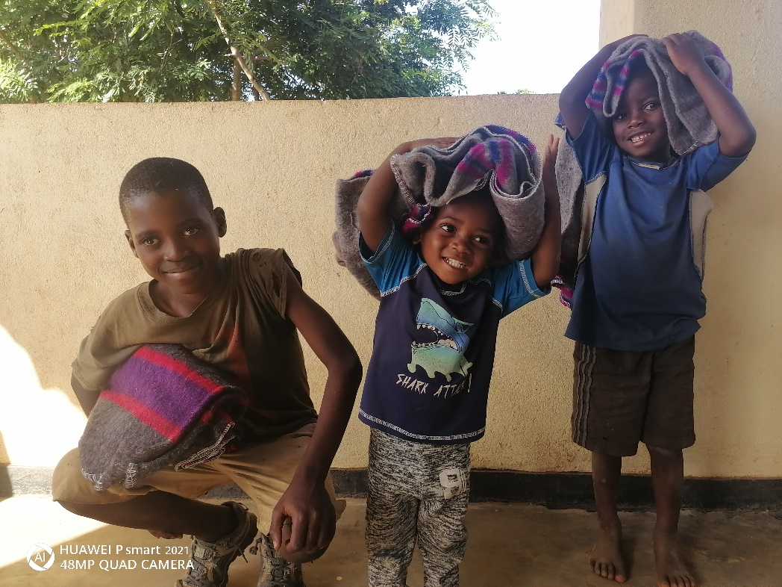

Beautiful smiles from siblings who all got blankets

